**Listening N° 2: How do you express positive feelings?**

**Name: Class: Date:**

Identificar palabras y frases clave, expresiones de uso frecuente, vocabulario temático, conectores (*first, second,* *next, finally, or, because, before, after,* *too when, while*), sonidos /*z*/*,* /*s*/ (*zoo*/ *sad*), sonido inicial /*h*/ (*hot*/*hour*) y los sonidos /*g*/ (*go*/*ago*/*egg*) *y* /*d3*/ (*jacket*/ *general*/*age*) en textos orales en diversos formatos o al participar en interacciones cotidianas y conversaciones en la clase.

**Objetivo de Aprendizaje 2**

**I. MAKE** mimics for the feelings your teacher will say to you. Your classmates will guess and write them in the spaces below.

d)

c)

b)

a)

Ç



**II.** **WRITE** a definition for each of the following words. Use your dictionary and as much English as possible.

a) Successful : __________________________________________________

b) Letter : _____________________________________________________

c) Awesome : __________________________________________________

d) Crush : _____________________________________________________

e) Blushing : ___________________________________________________

**III.** **ANSWER**  the following questions in pairs.

a) What do you think is the topic of the text you are going to listen to?

------------------------------------------------------------------------------------------------------------------------------------------------------------------------------------------------------------------

Image result for headphones logoIV. **LISTEN** to the text and UNDERLINE the key words present in the audio.

https://www.youtube.com/watch?v=JjuxgH6yj9o&t=134s

a. Our group project was really successful.

b. I was so sad when the teacher said that!

c. Anne, it looks that you have been happy all day.

d. I got a love letter today!

e. It just says “M” here.



VI. Order the sentences from the text chronologically. **WRITE** numbers from 1-5.

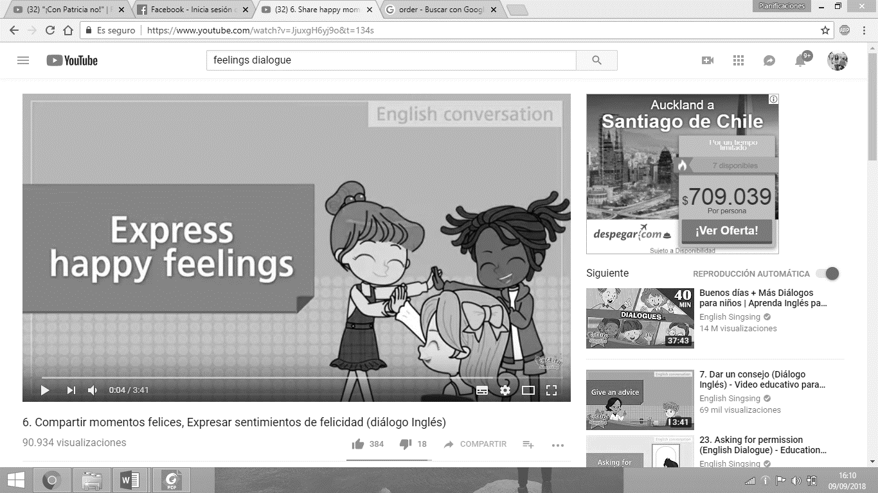

a. ______ One girl got a love letter.

b. ______ The girls were successful in the group project.

c. ______ One of the girls is blushing.

d. ______ The girls take their umbrellas.

e. ______ It begins raining.

Image result for headphones logo

VII. **LISTEN** to the text and paint the words that appear in the audio. Work with a partner.

**D. Got**

**C. Nervous**

**B. Angry**

**A. Same**

**H. Happy**

**G. Successful**

**F. Someone**

**E. Group**

****VIII. **LOOK** at these words from the audio. Pronounce them in pairs.

**Henry**

**Have**

**Here**

**Happy**



IX. **ANSWER** the following questions.

a. What do the words in activity 8 have in common?

________________________________________________________________________-

b. Did the words appear in the audio you listen before?

_________________________________________________________________________



X. **WRITE** sentences with the following words. Then, share with a partner.

Happy - got - envy - group

a. ________________________________________________________

b. _________________________________________________________

c. _________________________________________________________

d. ________________________________________________________

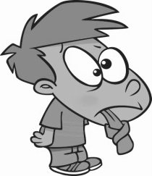

XI. Practice and present the following tongue twister to your classmates.

**Harry the hungry, hungry hippo is happily eating ham in his house.**